**Project Documentation: HSN Code Validation Agent (Google ADK Framework)**

**Project Overview**

The **HSN Code Validation Agent** is a modular intelligent agent built using the Google ADK (Agent Developer Kit) framework principles. It validates one or more HSN (Harmonized System Nomenclature) codes by checking:

* Format (length and numeric check)
* Existence in a provided master Excel dataset
* Hierarchical code validity

This agent is designed for **command-line** interface operation and is structured for future integration into chatbot or web applications.

**System Architecture**

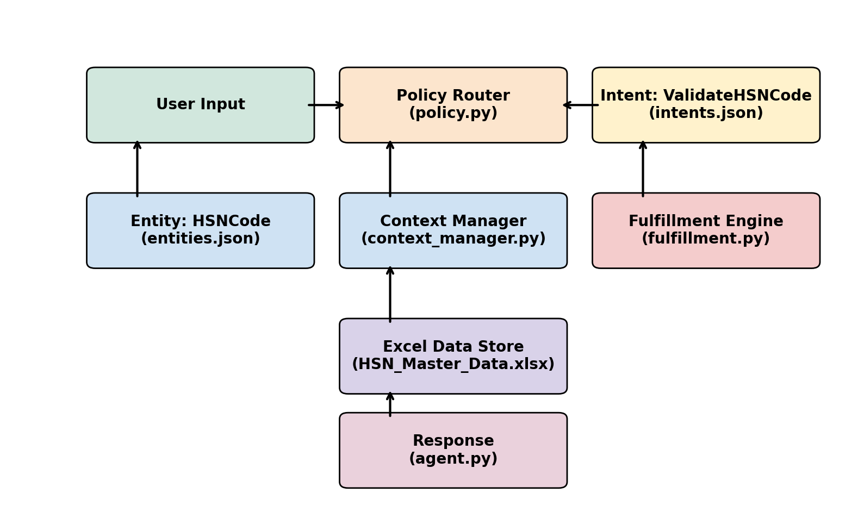

**ADK Component Mapping**

|  |  |
| --- | --- |
| ADK Component | Implementation |
| Intent | `ValidateHSNCode` (via keyword check) |
| Entity | `HSNCode` (extracted via regex) |
| Policy | `policy.py` (routes based on keywords or digit detection) |
| Context Manager | `context_manager.py` (extracts codes) |
| Fulfillment | `fulfillment.py` (loads Excel & validates) |
| Data Source | `HSN_Master_Data.xlsx` |

**Data Details**

File: `data/HSN_Master_Data.xlsx`

* Columns:
  + `HSNCode` (string): e.g., `01012100`
  + `Description` (string): e.g., `PURE-BRED BREEDING ANIMALS`
* Format Validity Rules:
  + Must be numeric only
  + Allowed lengths: 2, 4, 6, or 8 digits

**How to Run**

**Installation**

* pip install -r requirements.txt

**Run the Agent**

* python agent.py

**Sample Inputs**

* >> validate 01012100, 9999, 01A2

**Expected Outputs**

* 01012100 → Valid: PURE-BRED BREEDING ANIMALS
* 9999 → Code not found
* 01A2 → Invalid format (non-numeric)

**Directory Structure**

hsn-code-agent-adk/

* adk_components/
  + intents.json
  + entities.json
  + policy.py
  + context_manager.py
  + fulfillment.py
* data/
  + HSN_SAC.xlsx
* adk_agent_architecture.png
* agent.py
* requirements.txt
* README.md

**Extensibility Ideas**

* Chatbot Integration: Extend to Dialogflow or Rasa.
* Google Sheets Sync: Live updates from a shared dataset.
* Web Interface: Add a simple Flask or Streamlit UI.
* Suggestions: Recommend close matches if code is invalid.
* Data Feedback: Flag inconsistencies if patterns of invalid codes are seen.